To : All Parents of Lodge Group of Schools
Date: : Thursday, 19 January, 2017
Title: : Director’s Circular January 2017
Circular Number : 1/DIR/2017

Dear Parents,

- Morning Break for National Primary Students
Effective Monday, 16th January 2017, Primary 1 to Primary 3 students are allowed to eat and drink inside their respective classrooms during recess time. All lunches must be taken in the school canteen. Teaching Assistants will remain inside the classrooms to supervise and to ensure orderliness and cleanliness of the classrooms.
- UPSR Results 2016
Lodge National Primary School did well in 2016 UPSR (KSSR) examination. The school achieved a GPS (Gred Purata Sekolah) of 1.6. 10 students (11.2%) of the total 89 candidates obtained 6A. They were the first batch of candidates sitting for UPSR based on KSSR curriculum.
3. PT3 Results 2016
A total of 116 candidates from Lodge National Secondary registered for Pentaksiran Tingkatan 3 (PT3) last year. Our school recorded a 100% Grade A achievement in Sejarah and Kemahiran Hidup Bersepadu (Ekonomi Rumah Tangga), whereas over 90% of our candidates attained Grade A in Geografi and English (Speaking). There were 24 candidates (20.7%) who scored straight As in the assessment.

4. Cambridge Primary Checkpoint and Cambridge Secondary Checkpoint Results 2016

i. Students’ results obtained for Cambridge Primary Checkpoint Test 2016
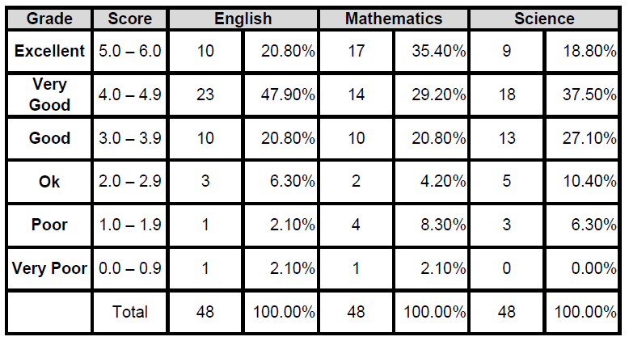
2016 was the first year that the Cambridge Primary Checkpoint Test was made compulsory for the Year 6 (Primary) students. The tests have been designed by Cambridge to assess students at the end of Cambridge Primary. They give valuable feedback on students’ strengths and weaknesses before they progress to the next stage of education. The test also provide our school with an external international benchmark for learner performance. Our teachers will work out strategies to improve students’ learning.

ii. Students’ results obtained for Cambridge Secondary Checkpoint Test 2016
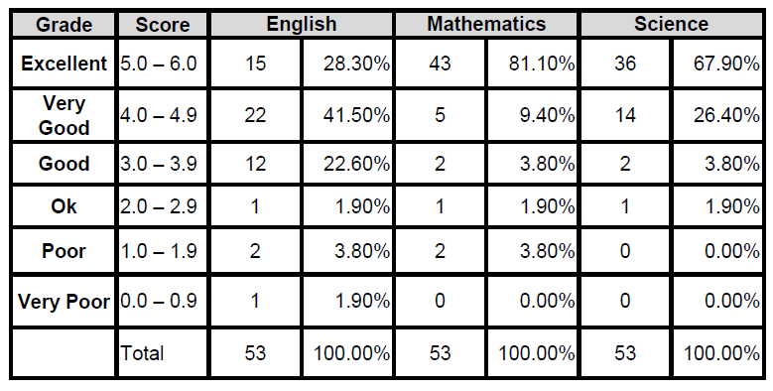
The percentage of students who attained scores of “excellent” has increased from 18.9% (10 out of 53 students) in 2015 to 26.4% (14 out of 53 students) in 2016.

5. Cambridge IGCSE

Cambridge IGCSE Examination Results (November 2016)

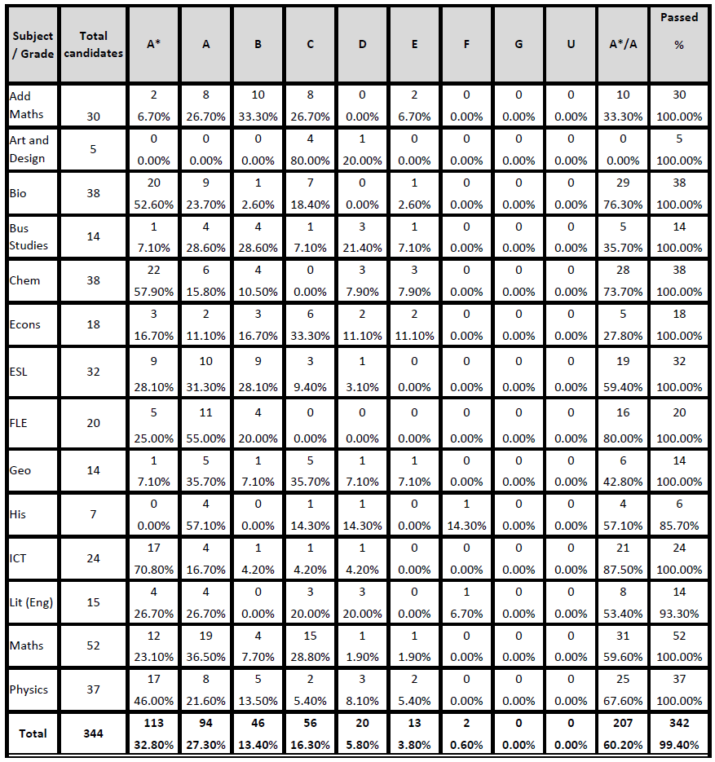
The class of 2016 achieved 100% passes in 12 IGCSE subjects. On the overall, students achieved 60.2% distinctions (A or A*) for all the subjects taken. Congratulations to the parents, teachers and students.

6. Cambridge International A Level (AS Results 2016)

Cambridge International AS Level Examination Results (November 2016)
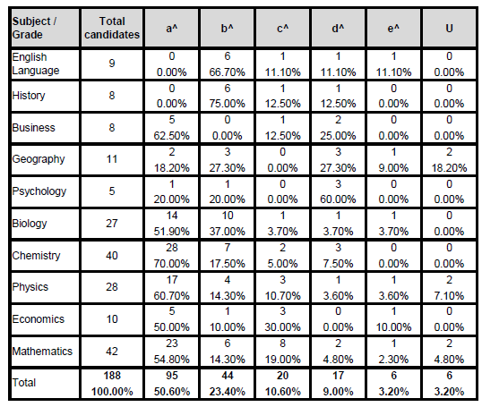

Lodge International School is extremely proud to announce that we have achieved our best AS-Level results since our A-Level inception and would like to congratulate parents and teachers as well as the students of the 2016 cohort for the outstanding result. The school celebrated a 98.6% pass rate for the AS-Level examinations. One out of three AS-Level candidates scored straight As in the examinations.

7. School Diary

Every student of Lodge Group of Schools is entitled a school diary. Information in the diary especially events planned for the year is intended for reference for all students, teachers and parents. There is also a section for students to record homework given so that they can keep track of what needs to be completed day to day. Parents are advised to look at their child’s diary to check this record. Students have been reminded not to lose their diaries. They need to buy a replacement should they lose them.
8. Traffic Arrangement in School Compound

All cars entering the school compound must have a valid school car sticker.

8.1 Lodge International School

Lodge International School students’ population has increased in 2017 and subsequently has led to the problem of car congestion in the school compound as well as a the public road access (Lorong Keranji 2A). For the convenience of all (Parents, Teachers and the Community), kindly observe the following measures when sending / fetching your children:
- There are 3 stopping bays in front of the lobby to drop / fetch your children. Kindly follow the instructions of the staff on duty.
- If you are early and need to park on the side of the road to wait for your children, DO NOT block the driveways of the neighbourhood. Turn on your car’s right signal light to let drivers behind know that you are waiting.
- From 3.00pm to 4.15pm, to ease the traffic flow along the school vicinity, the road (Lorong Keranji 2A) will be made into a 1 way traffic flow. Cars entering into the school from Lorong Keranji 2A will have to exit into Jalan Wan Alwi.

8.2 Lodge Kindergarten, National Primary and Secondary

- In National Primary School, 2 lanes will be open for more traffic flow in the afternoon for Tuesday and Thursday when dismissal time for both Primary and Secondary coincides.
- Parents are advised to keep the pick up lanes free. Do not wait on these lanes as you would be blocking traffic.
- In National Secondary School, we seek cooperation from parents who are in the pick up zone to keep the traffic flow. Two lanes are also designated for that purposes.

9. Blended Learning/Google Classroom and Google Drive for Children
Lodge Group of Schools is embarking on these strategies to help students learn 21st Century Skills. Besides normal text-based resources, students are also learning how to access digital information that they can source from the internet in addition to materials prepared by their teachers and delivered in digital format through Google Classroom. Students in the secondary as well as upper primary levels will be given Gmail account in stages to enable them to access Google Drive. This will also enable them to interact with their teachers and classmates on lessons learned in school. We would appreciate if parents could give us feedback on this initiatives.

10. Occasional Holidays and Festive Holidays in Conjunction with Festive Celebration
Starting from 2016, the Ministry of Education has issued a circular for schools in Malaysia to take festive leave for Chinese New Year, Hari Raya Aidilfitri and Deepavali. Lodge Group of Schools is abiding by this guideline. As such Lodge Group of Schools will break for Chinese New Year holidays on 26th January 2017 (Thursday) until 31st January 2017 (Tuesday). School will resume on 1st February 2017 (Wednesday). For Hari Raya Aidil Fitri, Lodge Group of Schools will be off from 26th June 2017 (Monday) to 30th June 2017 (Friday) as Hari Raya Aidil Fitri falls on 25th June 2017 (Sunday). Please note that this is an amendment to the earlier planning as shown in the school diary after this matter was deliberated during the Board of Management meeting on 19th January 2017.
As Deepavali is not public holiday in Sarawak, Lodge Group of Schools will not take festive or occasional holiday for the occasion. However, examination schedules will be adjusted to ensure that students finish their examinations before Deepavali, which falls on 18th October 2017.
11. Staff Movement

New Staff joining Lodge International School
Gladys Tan - Counsellor / Psychology (Year 12, 13) Teacher
Rajwant Kaur - Chemistry (Year 10, 11, 12) Teacher
Dr. Dai Lee - Global Perspective, Biology & Chemistry (Year 10, 12) Teacher
Chai Kuo Chun - Economics & History (Year 10, 11, 12) Teacher
Suzanna Adee - Geography (Year 8, 9, 10, 11) Teacher
Tan Ming Yee - Physics (Year 10, 12, 13) Teacher

New Staff joining Lodge National Secondary School
Wee Ying Thing - English, Pendidikan Seni Visual, Sejarah (Form 2)

New Staff joining Kindergarten and Primary School
Angeline Lim Sheau Yik (transfer from National Secondary)
Stephanie Kho Hui Ting
Syarifah Siffa Safiqah
Wendy Kon Siew Wee

Staff Retired/Discontinue Service
Lau Bee Lin (Kindergarten)
Edna Sim Yam Sam (National Primary)
Hazlina Mohd. Nawawi (National Primary)
Monica Yong (National Primary)
Nur Ashikin binti Hedzir (National Primary)
Chai Fook Vui (National Secondary)
Connie Lau Meaw Siok (National Secondary)
Lim Cher Kun (National Secondary)
Anne Chong (International)
Ling Ting Kuon (International)
Teresa Attley (International)
Amy Wong (International Administrative)
12. Student Attendance
Lodge Group of Schools will implement minimum school attendance policy to maintain standards. Students will not be given assessment and evaluation (Progressive Tests/Term Tests/School Exams) if they do not attend at least 85 % of school days in a term/year. Students who are frequently absent from school cannot be given proper assessment under School Based Assessment implemented in schools. Exception will be given to students on medical grounds and other reasons approved by the School only.
13. School Development Days
17th February 2017 (Friday) and 23rd October 2017 (Monday) have been designated as School Development Days. They will be implemented for the first time after the Board of Management granted its approval on 13th July 2016 to encourage capacity building of staff. On these days, teaching staff are to accomplish tasks set to enhance their pedagogical skills. As such School Development Days will be off days for students in Lodge Group of Schools.
14. Pre-Chinese New Year Celebration Activities
All entities will have Pre-Chinese New Year activities scheduled on 25th January 2017 (Wednesday). Primary school students will break off at 3pm and Secondary school students will break off at 3:30pm on that day.

On behalf of the Board of Management and all staff, I would like to wish everyone who is celebrating Chinese New Year a “Happy and Prosperous New Year”.

……………………………………….
Thomas Huo Kok Sen
Director
Lodge Group of Schools

